Name: _________________________________________ Date: ________
Lesson 1—Homework
No work = No credit

Write a ratio equivalent to $\frac{3}{7}$ with greater terms.

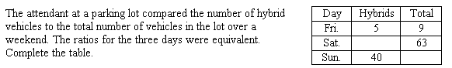

In a toy store, the ratio of the number of teddy bears to the number of dolls is 3:5. If the store has 120 teddy bears, how many dolls are in the store?

