Name: _________________________________________ Date: ________
Lesson 1—Homework
No work = No credit

Write a ratio equivalent to $\frac{3}{7}$ with greater terms.

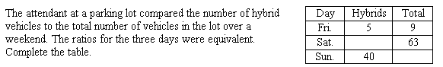

In a toy store, the ratio of the number of teddy bears to the number of dolls is 3:5. If the store has 120 teddy bears, how many dolls are in the store?
Write the ratio 15 inches to 9 feet as a fraction in simplest form. Explain why you get the same result whether you convert feet to inches or convert inches to feet. Why might you prefer one way over the other?

In basketball, some baskets are worth two points. Others are worth three points. In one game, the ratio of three-point baskets to three-point tries for one team was 3:8. If the team scored 36 points from three-point baskets, how many three-point tries did the team have?

A garden is 3 yards 12 inches wide and 2 yards long. Write the ratio of the width to the length as a fraction in simplest form.

