Name: _____________________________________________ Date: _________________
7A: Lesson 2—HOMEWORK
No Work = No Credit

You want to buy some beans. A 9-ounce package costs $3.33. A 14-ounce package costs $5.04. A 26-ounce package costs $10.14. Which package is the best buy? Explain how you know.

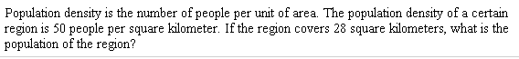

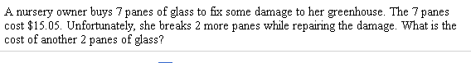

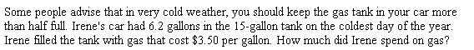

A warehouse store sells 4.5-ounce cans of tuna in packages of 5. A package of 5 cans costs $4.95. The store also sells 5.5-ounce cans of the same tuna in packages of 4. A package of 4 cans costs $5.28. The store sells 6.5-ounce cans in packages of 6 cans for $10.14. Which package is the best buy? Explain how you know.

An arts academy requires ther eto be 4 teachers for every 64 students and 5 tutors for every 55 students. How many students does the academy have per teacher. Per tutor? How many tutors does the academy need if it has 132 students?

