Name: _____________________________________________ Date: _________________
Lesson 4—HOMEWORK
No Work = No Credit

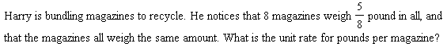

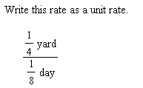

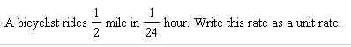

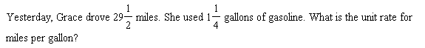

Hannah is making scones. The recipe calls for $\frac{5}{8}$ cup of flour to make 10 scones. What is the unit rate for cups of flour per scone? For scones per cup of flour?

